The Evolution of Vernalisation in Flowering Plants

In flowering plants, sensing environmental conditions and regulating flowering time is the key to maximising the potential for reproduction. Flowering too early can result in damage to the delicate reproductive organs during unseasonal cold snaps, while flowering too late means the plant can miss out on favourable growing conditions during spring. Crop planting schedules are planned specifically to exploit mechanisms for responding to these environmental cues, such as vernalisation, to maximise yield. While different plants respond differently on a genetic level, the overall response is regulation of the time a plant transitions from a vegetative growth state to a flowering one.

The Vernalisation Response

Vernalisation is characterised by a prolonged (i.e. greater than ten days) exposure to low but non-freezing temperatures. Vernalisation (from the Latin *vernum*, meaning *spring*), and its effect on harvest time and crop yield has been a central research focus of the plant biology community for over 150 years (Klippart 1857; Gassner 1918). The temperature at which the vernalisation response is triggered is dependent on the plant species and individual cultivar (see Table 1). It is theorised that the threshold temperature that triggers a vernalisation response can be calculated by examining the rate of plant growth under a range of temperatures, extrapolating the curve then selecting a temperature a few degrees above the inferred basal temperature (Angus et al. 1980). Sugar beet (*Beta vulgaris*) and carrot (*Daucus carota*) must be exposed to vernalisation before the plant is able to flower (an *absolute* vernalisation response) (Dijk et al. 1997; Alessandro et al. 2013). However, in wild populations, those growing in warmer temperatures require less exposure to vernalisation to trigger flowering. Where vernalisation is not essential for the transition to flowering (a *facultative* vernalisation response), such as in *Arabisopsis* *thaliana* (*Arabidopsis*) (Burn et al. 1993; Bastow et al. 2004), narrow leaf lupin (*Lupinus Augustifolius*) (Landers 1995), and winter wheat (*Triticum aestivum*) and barley (*Hordeum vulgare*) (Trevaskis et al. 2006; Oliver et al. 2009), the transition to flowering is triggered sooner than a plant which is unexposed (Sheldon et al. 2000). The genetic pathways of the vernalisation response are family-specific: not just between dicotyledonous (dicots) and monocotyledonous species (monocots), but also within different dicots (Reeves et al. 2007). Despite these differences, the gene pathways in vernalisation responsive plant species are epigenetic in nature (i.e. a vernalisation sensitive variety of a plant species will resulting in expression of a different phenotype when exposed to vernalisation conditions). These epigenetic changes are reset in the next generation.

In *Arabidopsis* and other dicots, the shoot tip is located at the crown of the plant and contains the shoot apical meristem (SAM) and is composed of a collection of pluripotent stem cells that slowly divide and differentiate into the various progenitor cells necessary for vegetative tissue growth (Meyerowitz 1997; Fletcher 2002). In *Poa pratensis* (Kentucky Bluegrass) and other monocots, the location of the pluripotent stems cells are in the basal meristem at the bottom of the plant, just above the soil line (Etter 1951). Regardless of location, after floral induction, the types of progenitor cells that the pluripotent meristem cells produce changes into those progeny cells necessary for the creation of tissues and structures for flowering. In 1962, Wellensiek (Wellensiek 1962) showed that in a number of plants with a SAM, moving vernalised shoot stock to non-vernalised root stock resulted in a vernalised plant. Similarly, moving non-vernalised shoot stock to vernalised root stock did not result in an expressed vernalised phenotype, meaning that while other organs may respond to vernalisation conditions, the most profound location for phenotypic expression of vernalisation in dicots is the shoot tip containing the SAM. Presumably, a similar effect would be seen in monocots, where grafting a basal meristem of a vernalised plant onto non-vernalised root stock would result in an expressed phenotype showing exposure to vernalisation, and vice versa. However, the literature is not clear in this regard.

Vernalisation in *Arabidopsis* *thaliana*

In *Arabidopsis*, the MADS-box (MCM1, AGAMOUS, DEFICIENS, and SRF, serum response factor) (Riechmann & Meyerowitz 1997) transcription factor Flowering Locus C (FLC) is the key mediator in the transition to flowering. Before vernalisation, *FLC* expression is promoted by *FRIGIDA* (*FRI*), *FRIGIDA-LIKE 1* (*FRL1*) and *FRIGIDA-LIKE 2* (*FRL2*) (Werner et al. 2005). While *FLC* is expressed, it represses *Flowering Locus T* (*FT*) expression (Sheldon et al. 2000). In the *Arabidopsis* ecotype *Col*-0, during FLC expression, VERNALISATION 2 (VRN2) binds with CURLY LEAF (CLF), SWINGER (SWN) and FERTILIZATION-INDEPENDENT ENDOSPERM (FIE) to form the VERNALISATION 2 (VRN2)/Plant Homeo domain Polycomb Repression Complex 2 (PHD-PRC2) (Köhler & Villar 2008). This protein complex is constitutively bound to the *FLC* locus, maintaining the locus in an open conformational shape via H3 acetylation and allows transcriptional machinery to access the *FLC* regulatory sequence and promote *FLC* expression (De Lucia et al. 2008).

When the *Arabidopsis* cultivar *Col*-0 is exposed to non-freezing cold, this triggers expression of *VERNALISATION INSENSITIVE 3* (*VIN3*), *VERNALISATION 5/VIN3-LIKE* (*VEL1*) and *VERNALISATION 5* (*VRN5*). The translated proteins bind to the VRN2/PHD-PCR2 complex to promote histone H3 deacetylation and *VRN2*-directed trimethylation of H3K9 and H3K27 at the *FLC* locus (Sung & Amasino 2004), while simultaneously demethylating the H3K4 promotor region upstreamof *FLC* (Finnegan et al. 2005). This closes the conformational shape of *FLC*, blocking transcriptional machinery from accessing the locus, thereby repressing *FLC* expression (Finnegan & Dennis 2007). This epigenetic repression of *FLC* is stable and irreversible, ensuring the transition to a flowering state is permanent (Levy et al. 2002).

When the *FLC* locus is closed, *FLOWERING TIME* (*FT*), its homolog *TWIN SISTER OF FT* (*TSF*), and *SUPPRESSOR OF OVEREXPRESSION OF CONSTANS 1* (*SOC1*) can then be expressed. FT travels through the phloem and into meristem tissues (Corbesier et al. 2007). Once there, FT triggers floral induction by transitioning meristem cells to a reproductive state by promoting *LEAFY* (*LFY*) and *APETALA1* (*AP1*), the two primary promoters of floral apical meristem growth (Amasino 2004). These then cause pluripotent cells in the SAM to differentiate and divide into reproductive tissues and eventually flowering bodies.

There are another five homologs of FLC within *Arabidopsis* that are regulated by vernalisation. Expression of *MADS AFFECTING FLOWERING1* (*MAF1*)through *MAF4* are all downregulated by vernalisation, whereas *MAF5* is upregulated (Ratcliffe et al. 2003). Different isoforms of *MAF2* are expressed at different temperatures, with *maf2* mutants

RE: Figure 1. How does FT expression increase during winter? Where is the long-day signal??

The cereal VRN2 gene is not expressed in SD so is not repressed by cold. Best to have it off completely in winter (less than 10 hour days is a threshold)

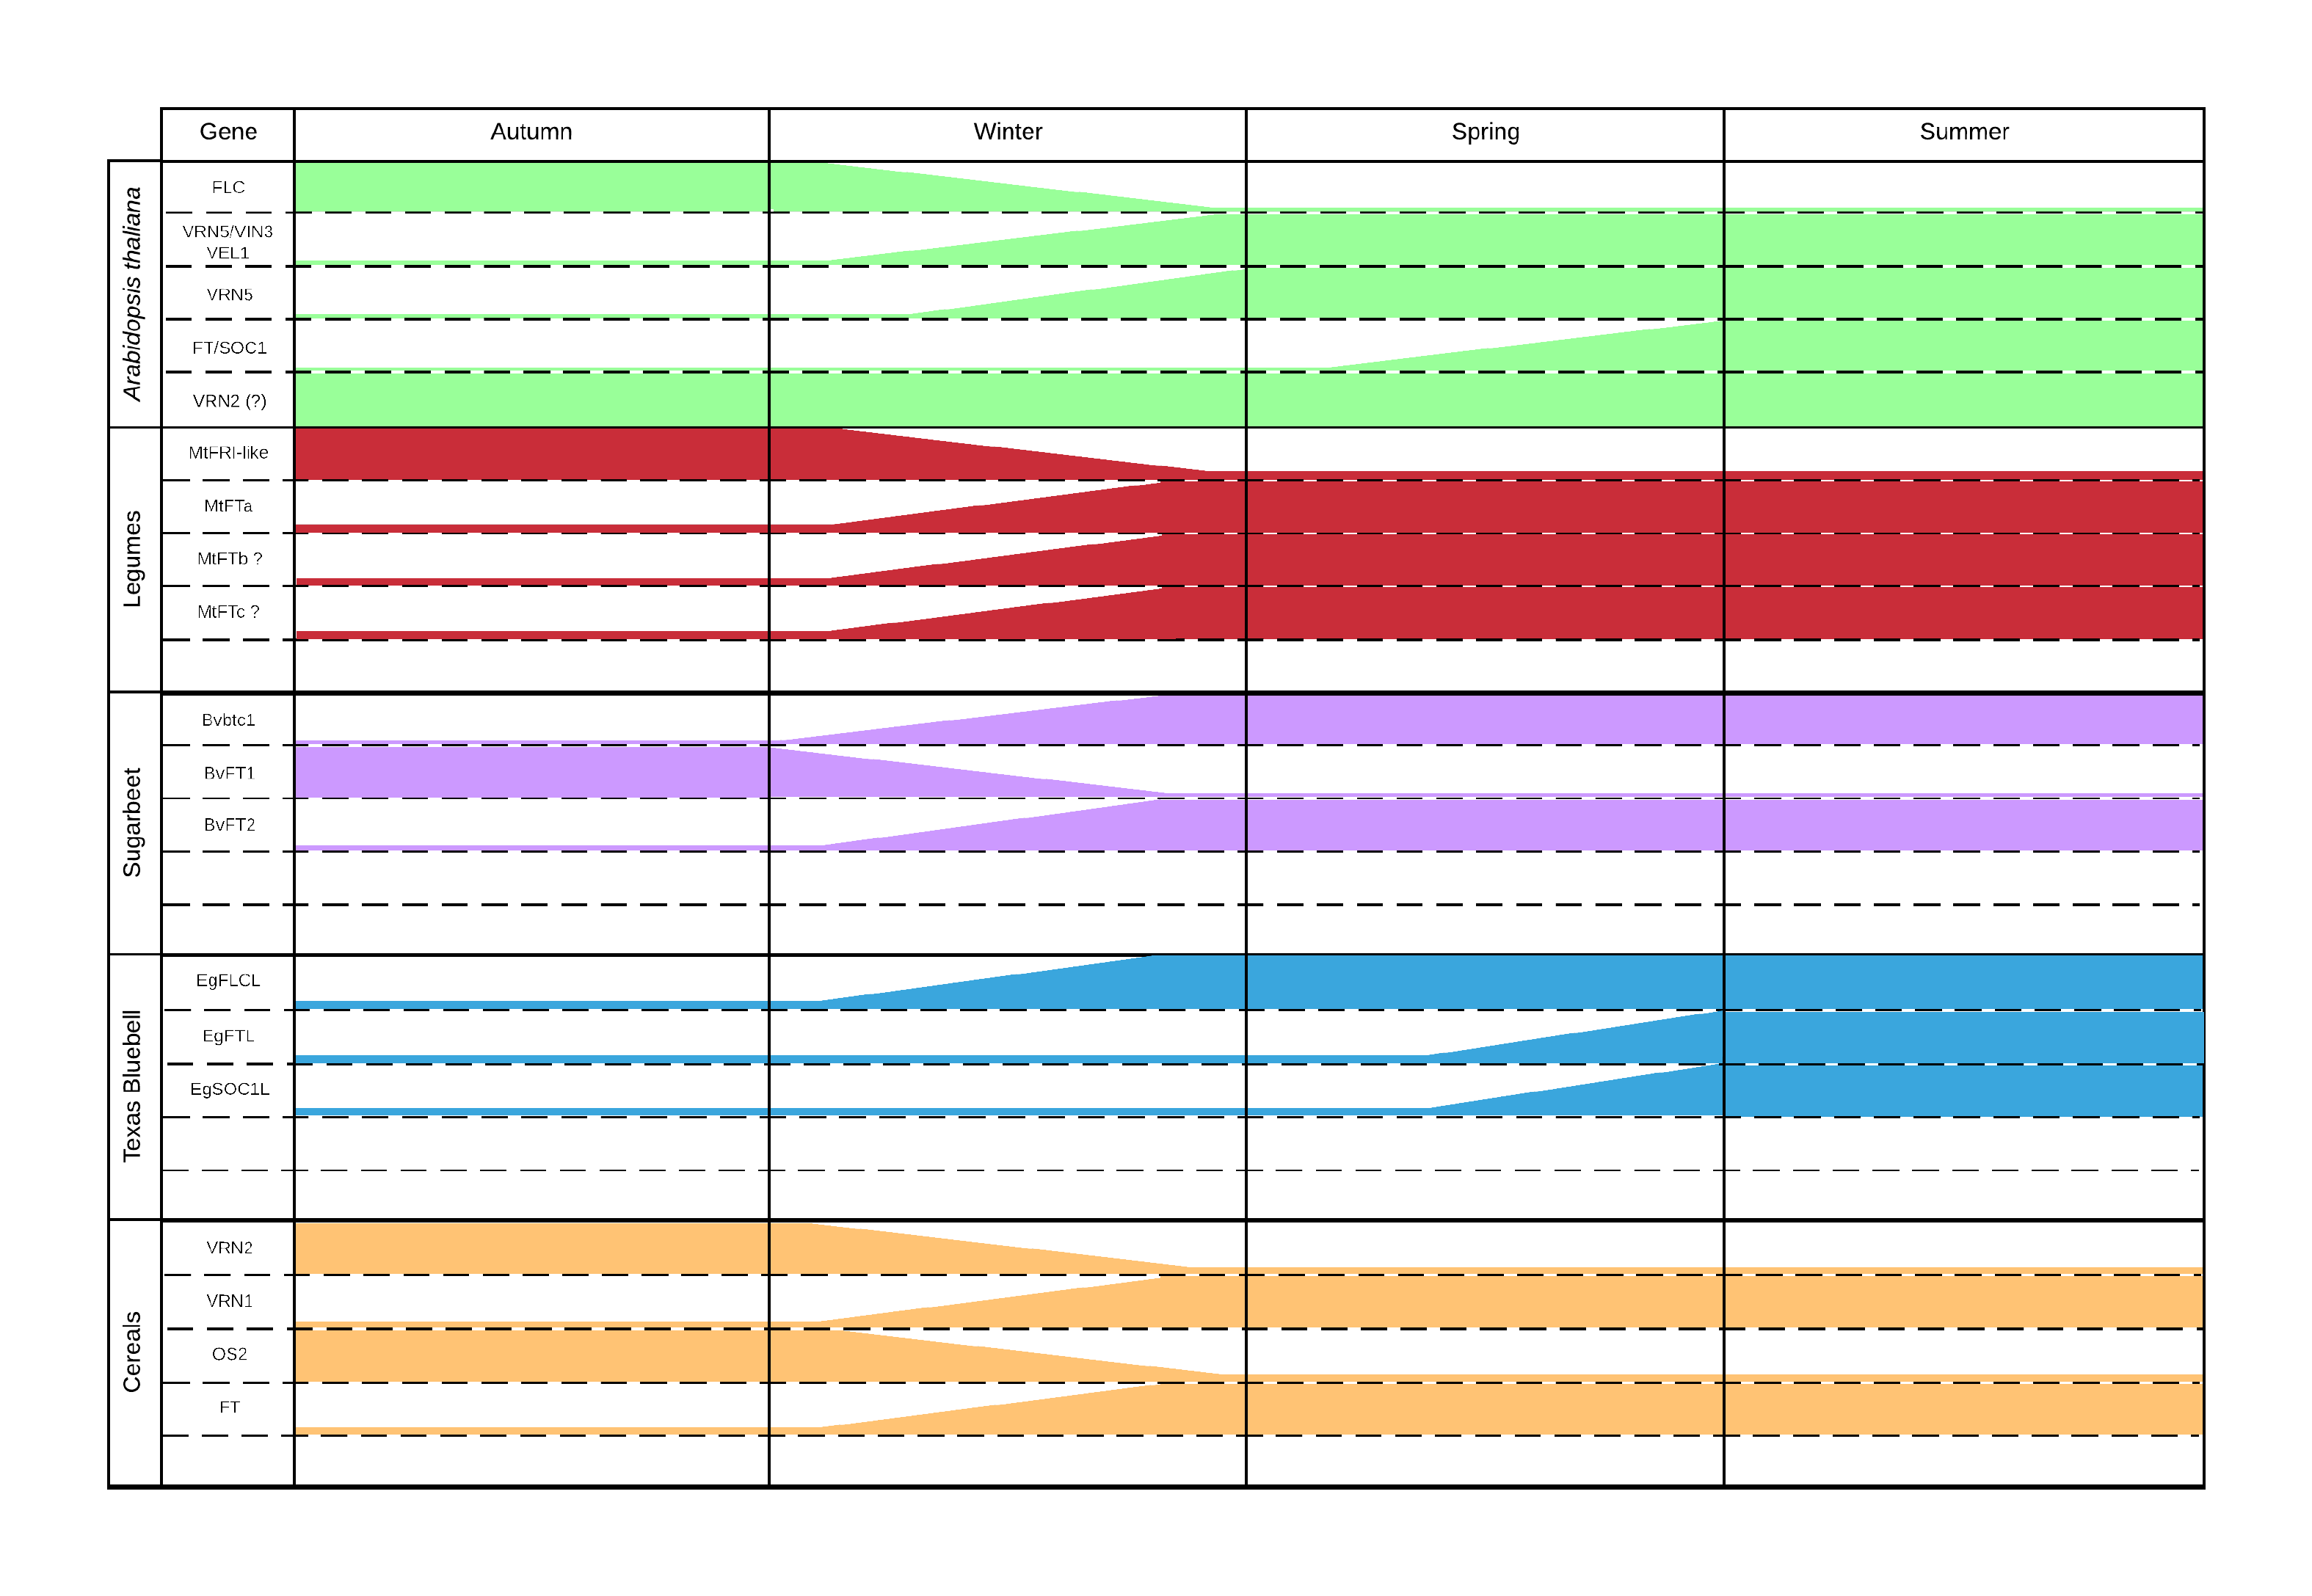

Figure 1 – Summary of genes expressed in several plant species after exposure to vernalisation conditions.

showing an inability to repress flowering at low temperatures (Airoldi et al. 2015). This indicates that while *FLC* is still the primary regulator of flowering time and main target of regulation by vernalisation, it does not act as the sole regulator. Modifications to genes upstream of *FLC* regulate its expression, not just *flc* mutants. Natural variations in *FRI* in *Arabidopsis* ecotypes resulting in low FRI levels have been shown to decrease the time to flowering, meaning the presence of *FRI* promotes expression of *FLC* (Werner et al. 2005). Similarly, *vin3* loss of function mutants are shown to lose the ability to detect cold, meaning the plant no longer responds to vernalisation (Sung & Amasino 2004).